Cloud Computing Project Documentation
Course: Cloud Computing
Project: Cloud-Based Learning Platform

Github repo

Phase 1: AWS Infrastructure Layer
(EC2 & EBS Implementation)
Objective of Phase 1
The objective of Phase 1 was to build the infrastructure layer that will host all microservices and backend components of the cloud-based learning platform using AWS services.

EC2 & EBS
EC2 Instance Creation
I created multiple EC2 instances to support different roles in the system:
Container Hosts
Used to run Docker containers for microservices
Instance type: t3.medium
OS: Linux (Amazon Linux)
Security Group: container
Kafka Brokers
Used for message streaming between services
Zookeeper Node
Used for Kafka coordination
Later, I selected one main container host for my services and renamed it to:
container-host-d-q
This instance became the main execution environment for my microservices.

EBS (Elastic Block Store)
Each EC2 instance was automatically attached to an EBS root volume
EBS volumes provide persistent storage for:
OS files
Docker data
Logs
Volumes were encrypted by default

Launch Templates
Launch templates were created to standardize EC2 configuration
Included:
Instance type
AMI
Security group
Key pair
These templates allow future scaling or recreation of instances easily

Security Groups
Security groups were configured to control traffic:
Purpose | Port
SSH access | 22
Application traffic | 80 / 8080
Kafka communication | 9092
Zookeeper | 2181
This ensures secure communication inside the VPC.

VPC Creation:
Name: aiu-learning-platform-vpc
IPv4 CIDR: 10.0.0.0/16

Tier | Subnet CIDR | Availability Zone | Purpose
Public | 10.0.1.0/24 | AZ-1 | Application Load Balancer, NAT Gateway
Public | 10.0.2.0/24 | AZ-2 | Application Load Balancer, NAT Gateway
Private | 10.0.10.0/24 | AZ-1 | ECS backend services
Private | 10.0.11.0/24 | AZ-2 | ECS backend services
Kafka | 10.0.30.0/24 | AZ-1 | Kafka Broker & Zookeeper
Kafka | 10.0.31.0/24 | AZ-2 | Kafka Broker & Zookeeper
Data | 10.0.20.0/24 | AZ-1 | RDS database
Data | 10.0.21.0/24 | AZ-2 | RDS database
VPC Diagram
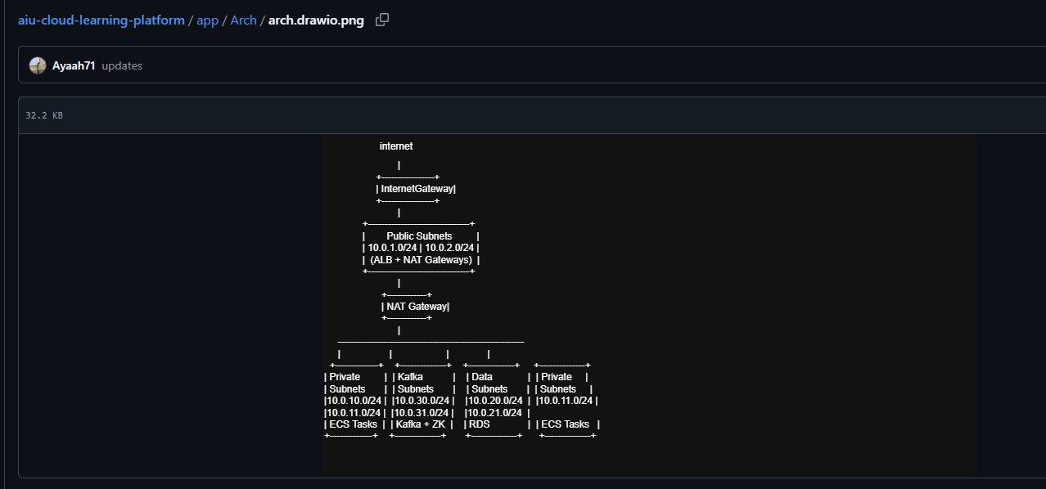

Network ACLs Rules

Rule # | Direction | Protocol | Port Range | Source | Action
100 | Inbound | TCP | 80 | 0.0.0.0/0 | ALLOW
110 | Inbound | TCP | 443 | 0.0.0.0/0 | ALLOW
120 | Inbound | TCP | 1024–65535 | 0.0.0.0/0 | ALLOW
100 | Outbound | ALL | ALL | 0.0.0.0/0 | ALLOW
Private / Kafka / Data Subnet Network ACL
Rule # | Direction | Protocol | Port Range | Source | Action
100 | Inbound | ALL | ALL | 10.0.0.0/16 | ALLOW
100 | Outbound | ALL | ALL | 0.0.0.0/0 | ALLOW
Security Groups
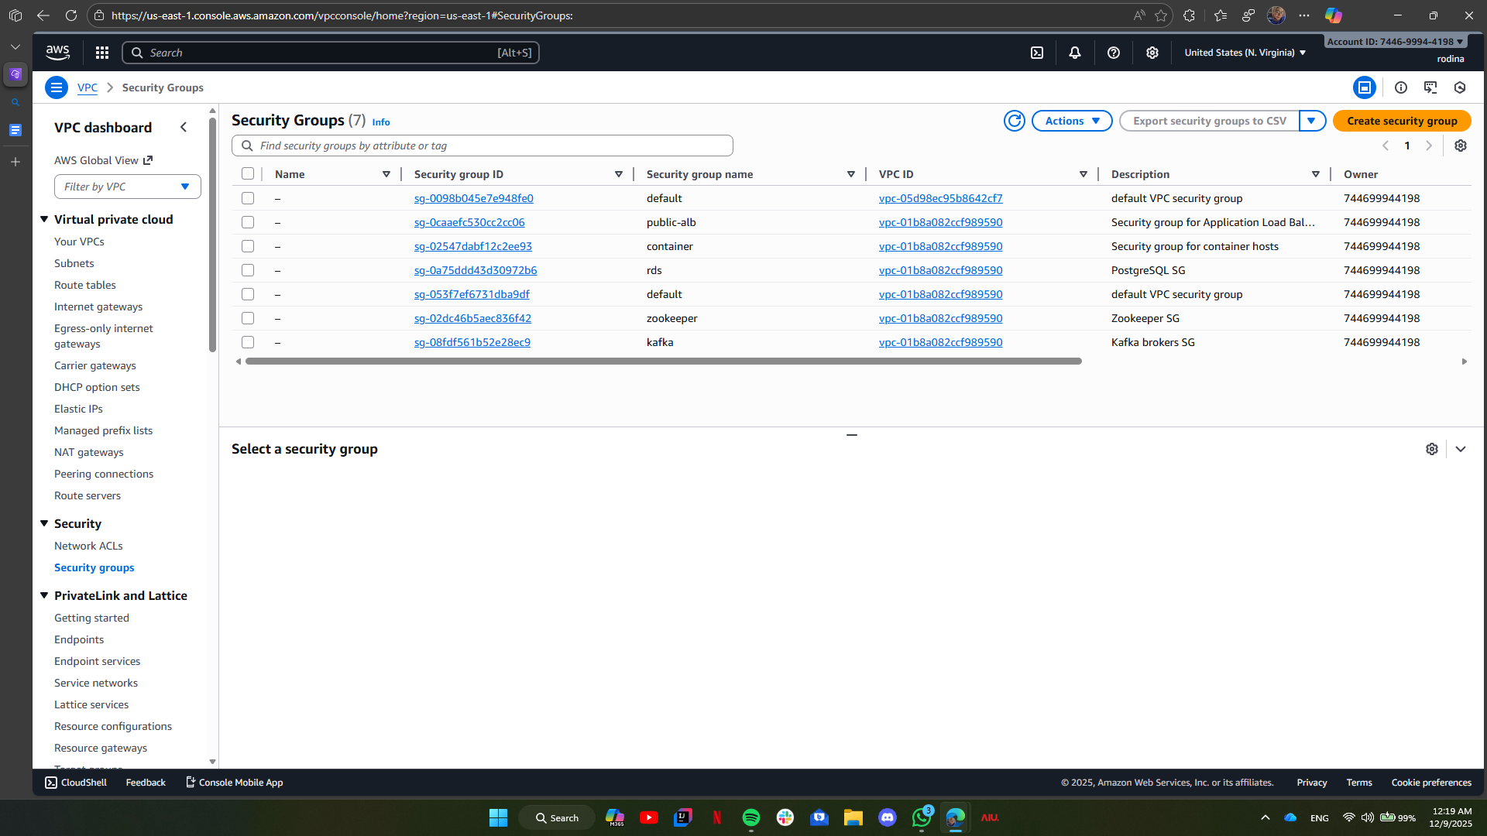

AWS Lambda Functions
document-upload-processor
Runtime: Python 3.11
Deployment type: Zip
Purpose: Triggered by S3 events to process uploaded documents
storage-cleanup-job
Runtime: Python 3.11
Deployment type: Zip
Purpose: Periodic cleanup of old or unused files from storage
kafka-consumer-monitor
Runtime: Python 3.11
Deployment type: Zip
Purpose: Monitors Kafka consumer health and lag
scaling-decision
Runtime: Python 3.11
Deployment type: Zip
Purpose: Supports automated scaling decisions based on system metrics

note :
AWS Lambda functions are used to handle background and serverless tasks such as document processing, cleanup jobs, Kafka monitoring, and scaling decisions without managing servers.

Load Balancers
api-alb-dev
Type: Application Load Balancer (ALB)
Scope: Internet-facing
Purpose: Handles HTTP traffic for all API and microservices
kafka-nlb-dev
Type: Network Load Balancer (NLB)
Scope: Internal
Purpose: Handles Kafka and Zookeeper TCP traffic

Target Groups
API Gateway
tg-api-gateway
Chat Service (Blue–Green)
tg-chat-blue
tg-chat-green
tg-chat-service
Document Reader Service (Blue–Green)
tg-document-blue
tg-document-green
tg-document-reader
Quiz Service (Blue–Green)
tg-quiz-blue
tg-quiz-green
tg-quiz-service
STT Service (Speech-to-Text) (Blue–Green)
tg-stt-blue
tg-stt-green
tg-stt-service
TTS Service (Text-to-Speech) (Blue–Green)
tg-tts-blue
tg-tts-green
tg-tts-service
Kafka & Zookeeper
tg-kafka-brokers
tg-zookeeper

note :
Each microservice has its own target group, and Blue–Green target groups are used to support zero-downtime deployments and rollback. Kafka services are attached to the Network Load Balancer, while all APIs are routed through the Application Load Balancer.

Amazon RDS Database Deployment
Overview
As part of Phase 1 of the project, two databases were successfully deployed on Amazon RDS using the PostgreSQL engine. These databases were provisioned following AWS best practices for security, network isolation, and high availability. The databases support the following services:
User Management Service
Chat Service
Due to account limitations, only these two databases were created in this phase. The remaining services (Document Reader Service and Quiz Service) will be implemented in subsequent phases.
Implemented Databases
1. user-management-db
Engine: PostgreSQL
Endpoint: user-management-db.<unique-id>.us-east-1.rds.amazonaws.com
Master Username: postgres
Encryption: Enabled using AWS KMS
Backup: Automated backups enabled with 7-day retention
Subnet Group: Private subnets within the VPC
Security Group: Access restricted to EC2 instances within the same VPC
2. chat-service-db
Engine: PostgreSQL
Endpoint: chat-service-db.<unique-id>.us-east-1.rds.amazonaws.com
Master Username: postgres
Encryption: Enabled using AWS KMS
Backup: Automated backups enabled with 7-day retention
Subnet Group: Private subnets within the VPC
Security Group: Access restricted to EC2 instances within the same VPC

Security and Compliance
Encryption: All data at rest is encrypted using AWS KMS.
Network Isolation: Databases are deployed in private subnets to prevent public access.
Access Control: Security groups allow connections only from trusted EC2 instances within the same VPC.
Backup Strategy: Automated backups with a retention period of 7 days ensure data durability and recovery.
Next Steps
Provision databases for:
Document Reader Service
Quiz Service
Continue following AWS best practices for security, scalability, and cost optimization.
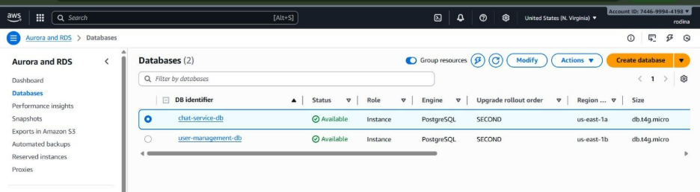
S3 Buckets Creation
Created isolated S3 buckets for each service to ensure storage separation:
tts-service-storage-dev-m
stt-service-storage-dev-r
chat-service-storage-dev-a
document-reader-storage-dev-m
quiz-service-storage-dev-n
shared-assets-dev-t
Enabled server-side encryption (SSE-KMS) to protect data at rest.
Enabled versioning on all buckets for data recovery.
Applied service-specific IAM policies to enforce access control, restricting each service to its own bucket.

IAM

IAM ROLES:-
container-host-role kafka-broker-role zookeeper-node-role lambda-execution-role
microservice-service-account-role IAM USERS:-
developer1
IN group nameD :developers

admin1
IN GROUP NAMED : admins

After that I enabled MFA for admin users device name:admin1-MFA username:admin1 pass:Maryam_55555
then MFA

JSON for OUR buckets:

1tts-s3-policy → tts-service-storage-dev-m
{
"Version": "2012-10-17",
"Statement": [
{
"Effect": "Allow", "Action": [ "s3:GetObject", "s3:PutObject"
"Resource": "arn:aws:s3:::tts-service-storage-dev-m/*"
}
]
}

³stt-s3-policy → stt-service-storage-dev-r
{
"Version": "2012-10-17",
"Statement": [
{
"Effect": "Allow", "Action": [ "s3:GetObject", "s3:PutObject"
],
"Resource": "arn:aws:s3:::stt-service-storage-dev-r/*"
}
]
}

³⬛ chat-s3-policy → chat-service-storage-dev-a
{
"Version": "2012-10-17",
"Statement": [
{
"Effect": "Allow", "Action": [

"s3:GetObject", "s3:PutObject"
],
"Resource": "arn:aws:s3:::chat-service-storage-dev-a/*"
}
]
}

Gquiz-s3-policy → quiz-service-storage-dev-n
{
"Version": "2012-10-17",
"Statement": [
{
"Effect": "Allow", "Action": [ "s3:GetObject", "s3:PutObject"
],
"Resource": "arn:aws:s3:::quiz-service-storage-dev-n/*"
}
]
}

document-reader-s3-policy → document-reader-storage-dev-m
{
"Version": "2012-10-17",
"Statement": [

{
"Effect": "Allow", "Action": [ "s3:GetObject", "s3:PutObject"
],
"Resource": "arn:aws:s3:::document-reader-storage-dev-m/*"
}
]
}

shared-assets-s3-policy → shared-assets-dev-t
{
"Version": "2012-10-17",
"Statement": [
{
"Effect": "Allow", "Action": [ "s3:GetObject", "s3:PutObject"
],
"Resource": "arn:aws:s3:::shared-assets-dev-t/*"
}
]
}

Service / Resource | IAM Role  / User | Allowed Actions | Notes / MFA
Container Hosts (EC2) | container- host-role | EC2:FullAccess, CloudWatchAgentServerPolicy, S3 access via policies | Role for Docker/Kubern etes hosts
Kafka Brokers (EC2) | kafka- broker-role | EC2:FullAccess, CloudWatchLogsFullAccess, S3 access via policies | Role for Kafka brokers
Zookeeper Nodes (EC2) | zookeeper- node-role | EC2:FullAccess, CloudWatchLogsFullAccess | Role for Zookeeper nodes
Lambda Functions | lambda-s3-processor | AWSLambdaBasicExecutionRole + AmazonS3ReadOnlyAccess | Role for lambda s3 processor
 | lambda-cleanup | AWSLambdaBasicExecutionRole + AmazonS3FullAccess | Role for Lambda cleanup
 | lambda-kafka-monitor | AWSLambdaBasicExecutionRole + AmazonEC2ReadOnlyAccess + CloudWatchFullAccess | Role for lambda kafka monitor
 | lambda-scaling-decision | AWSLambdaBasicExecutionRole + CloudWatchReadOnlyAccess + AutoScalingReadOnlyAccess | Role for lambda scaling
Microservi ces | microservi ce-service- account- role | S3 access, RDS connect as needed | Role for containerized apps
Developers | developer1 (in group: developers  ) | Read-only access (EC2, S3, CloudWatch) | No MFA
Admins | admin1 (in group: admins) | AdministratorAccess | MFA enabled, device: admin1-MFA
TTS  Service S3 | container- host-role / microservi ce-service- account- role | s3:GetObject, s3:PutObject | via tts-s3- policy
STT  Service S3 | container- host-role / microservi ce-service- account- role | s3:GetObject, s3:PutObject | via stt-s3- policy
Chat Service S3 | container- host-role / microservi ce-service- account- role | s3:GetObject, s3:PutObject | via chat-s3- policy

Quiz Service S3 | container- host-role / microservi ce-service- account- role | s3:GetObject, s3:PutObject | via quiz-s3- policy
Document Reader S3 | container- host-role / microservi ce-service- account- role | s3:GetObject, s3:PutObject | via document- reader-s3- policy
Shared Assets S3 | container- host-role / microservi ce-service- account- role | s3:GetObject, s3:PutObject | via shared- assets-s3- policy

Role Separation Benefits
Role Type | Purpose | Key Policies | Why Chosen
container-host-role | EC2/Docker hosts | EC2FullAccess + service S3 policies | Runs all microservices; needs broad EC2 but scoped S3
microservice-service-account-role | Container apps | Service-specific S3 | Kubernetes pods/EC2 tasks assume for S3 without keys
kafka/zookeeper roles | Messaging infra | EC2/CloudWatch + minimal S3 | Streaming support; no direct S3 needed usually
developer1 group | Read-only dev access | EC2/S3/CloudWatch read | Safe experimentation without production changes
admin1 (MFA) | Full admin | AdministratorAccess | Compliance; MFA blocks console access without device
Phase 1 Concept Summary
Phase 1 focuses on building machines, storage, and network rules.
No application logic runs here it only prepares the environment.

Phase 2: Microservices Development
(Document Reader & Quiz Service)
Objective of Phase 2
The goal of Phase 2 was to design and deploy microservices that perform application logic using containerization and event-driven communication.

Document Reader Service
Quiz Service

What we Implemented
Local Service Development
For each service, I created:
Python application (app.py)
Dependencies file (requirements.txt)
Dockerfile for containerization

Docker Containerization
I containerized both services using Docker.
Example Docker build command:
docker build -t document-reader-service:v1 .
docker build -t quiz-service:v1 .

Amazon ECR (Elastic Container Registry)
Created ECR repositories:
document-reader-service
quiz-service
Tagged Docker images for ECR
Attempted to push images to ECR

Issues Faced in Phase 2 (Important & Honest)
Despite correct local builds, I faced connection and authentication issues when integrating Phase 2 services with AWS:
AWS CLI was not recognized on local machine initially
ECR authentication failed multiple times
Docker push commands returned:
authorization failed: no basic auth credentials
Service containers could not be fully connected and run on EC2

Why This Happened (Technical Reason)
Phase 2 requires correct IAM roles, AWS CLI setup, and Docker authentication, which caused delays and prevented full deployment.

Commands Required to Connect Phase 2 Services to AWS
Login to ECR from EC2
aws ecr get-login-password --region us-east-1 \
| docker login --username AWS --password-stdin <account-id>.dkr.ecr.us-east-1.amazonaws.com
Pull Docker Images
docker pull <ECR-URI>/document-reader-service:v1
docker pull <ECR-URI>/quiz-service:v1
Run Containers
docker run -d -p 8081:8080 document-reader-service:v1
docker run -d -p 8082:8080 quiz-service:v1

Creating Kafka & Zookeeper
Using this:
For kafka :
sudo docker run -d --name kafka \
--network kafka-net \
-e KAFKA_BROKER_ID=1 \
-e KAFKA_ZOOKEEPER_CONNECT=zookeeper:2181 \
-e KAFKA_LISTENERS=PLAINTEXT://0.0.0.0:9092 \
-e KAFKA_ADVERTISED_LISTENERS=PLAINTEXT://10.0.1.61:9092 \
-e KAFKA_OFFSETS_TOPIC_REPLICATION_FACTOR=1 \
-p 9092:9092 \
confluentinc/cp-kafka:7.4.2

For zookeeper:
sudo docker run -d --name zookeeper \
--network kafka-net \
-p 2181:2181 \
-v /home/ec2-user/zookeeper-data:/data \
-e ZOO_MY_ID=1 \
-e ZOO_PORT=2181 \
-e ZOO_TICK_TIME=2000 \
-e ZOO_INIT_LIMIT=5 \
-e ZOO_SYNC_LIMIT=2 \
zookeeper:3.6.3
And for creating the topics:
TOPICS=(
document.uploaded
document.processed
notes.generated
quiz.requested
quiz.generated
audio.transcription.requested
audio.transcription.completed
audio.generation.requested
audio.generation.completed
chat.message
)

for topic in "${TOPICS[@]}"; do
sudo docker exec -it kafka /usr/bin/kafka-topics \
--create \
--bootstrap-server 10.0.1.61:9092 \
--replication-factor 1 \
--partitions 3 \
--topic "$topic"
done

I did it on kafka broker1 but suddenly kafka & zookepeer stopped working so i used kafka broker 2 and started it all again
I created the producer & consumer using this:
And finally the producer sends a message to the consumer

# Produce a message
sudo docker exec -it kafka /usr/bin/kafka-console-producer \
--bootstrap-server 10.0.1.61:9092 \
--topic document.uploaded
>Test document upload
# Press Enter to send

# Consume the message
sudo docker exec -it kafka /usr/bin/kafka-console-consumer \
--bootstrap-server 10.0.1.61:9092 \
--topic document.uploaded \
--from-beginning
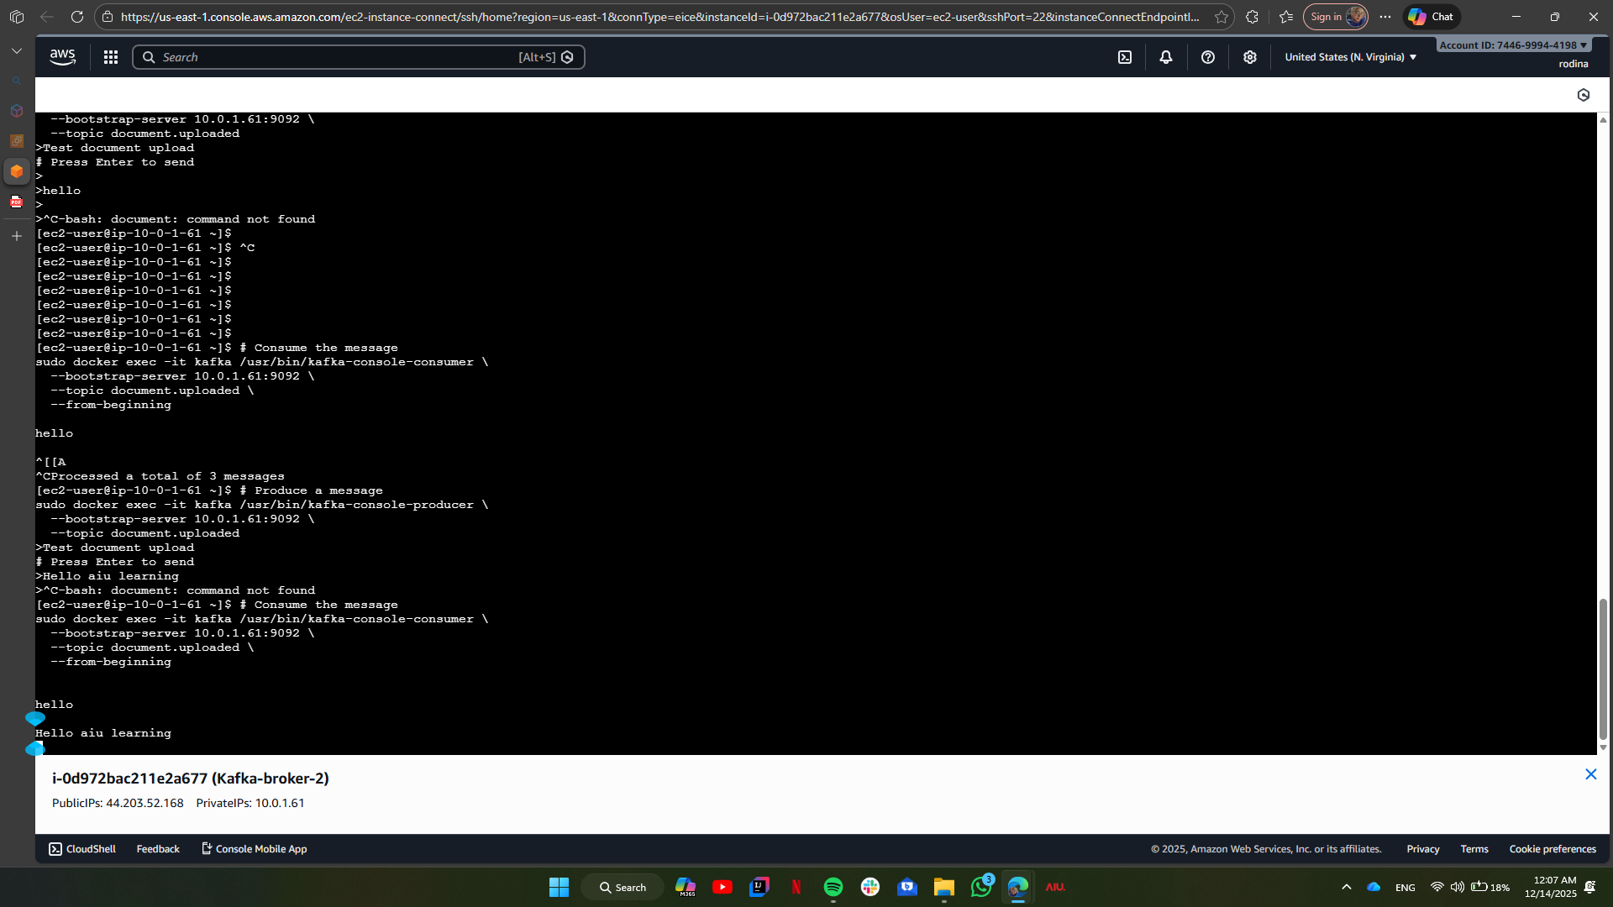
API Gateway Implementation
1.Authentication flow diagrams
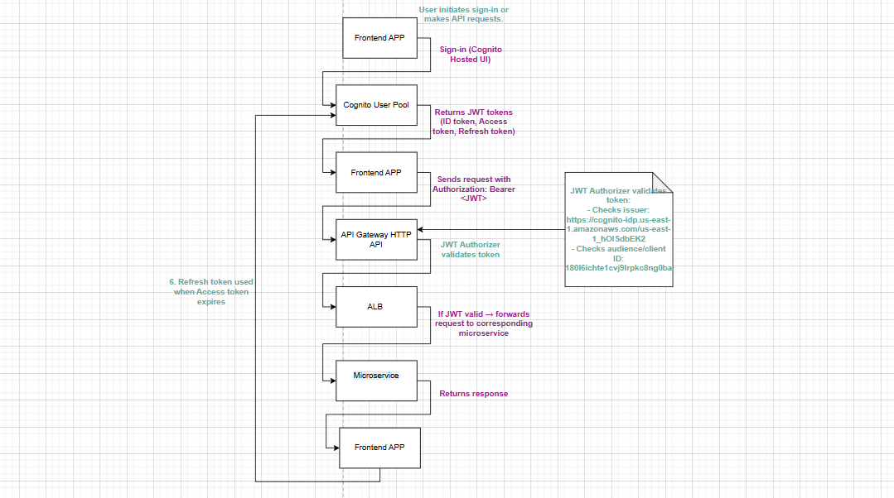

2.API documentation
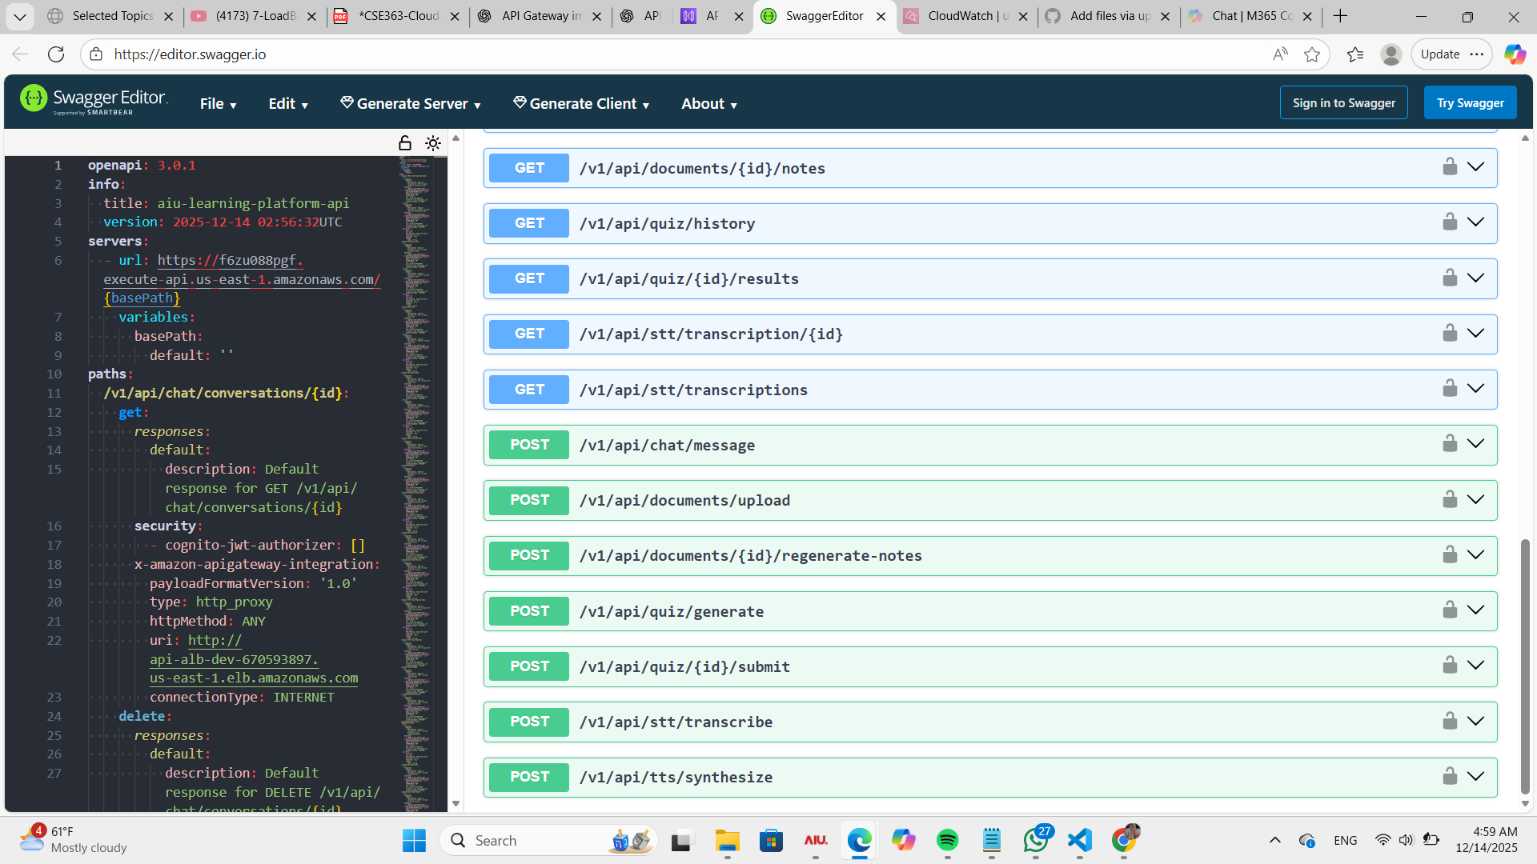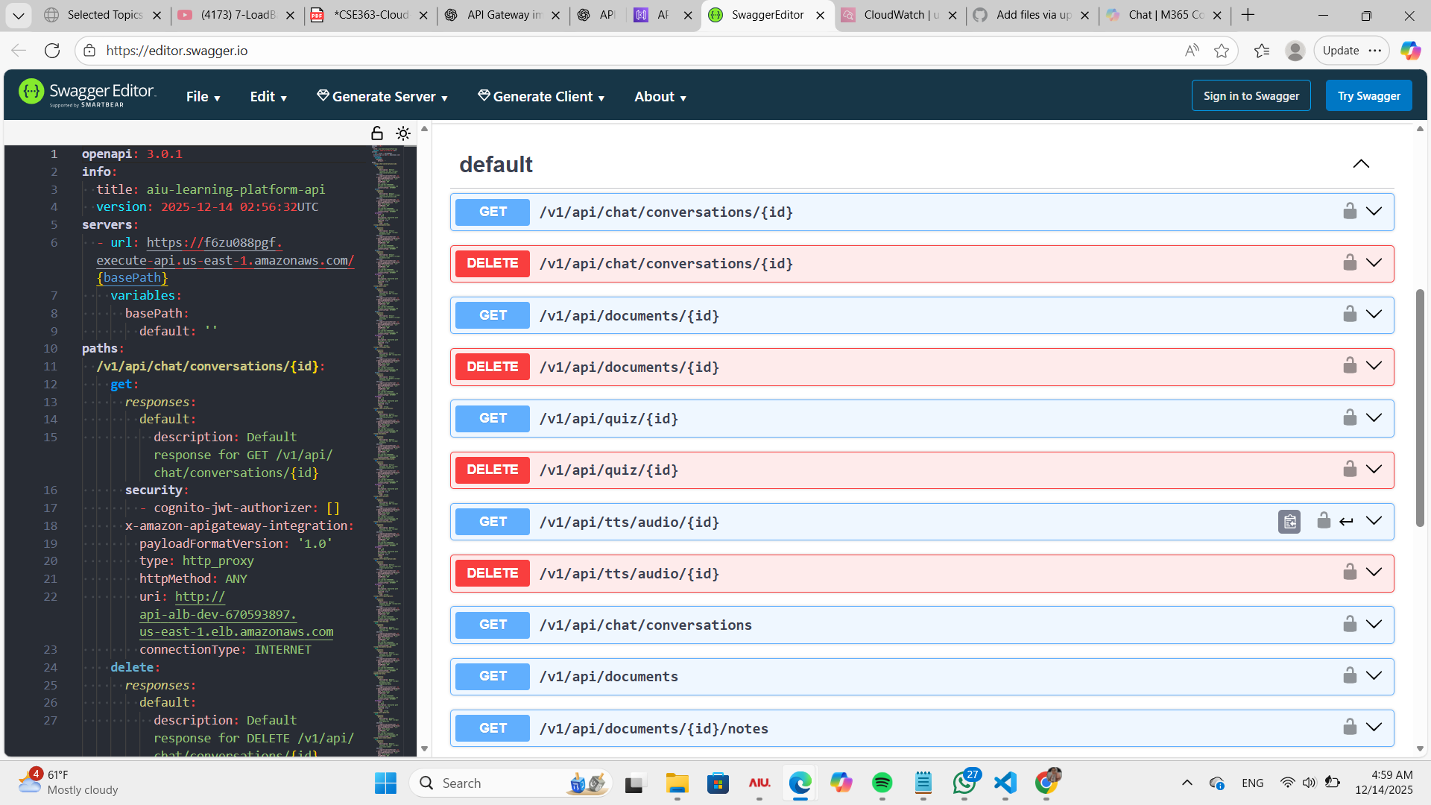

3.Rate limiting policies
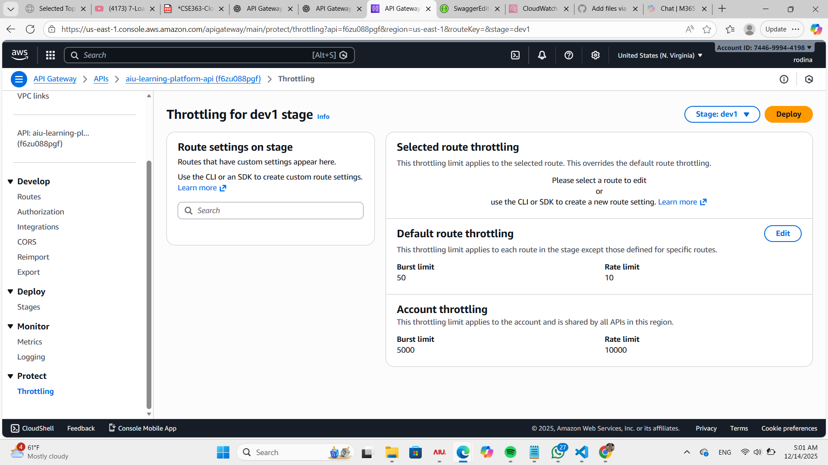

Text-to-Speech (TTS) Service

1. Overview
The Text-to-Speech (TTS) service is a core microservice in the Cloud-Based Learning Platform. Its primary function is to convert text input into natural-sounding speech, supporting multiple languages and audio formats. This service is designed to operate within a microservices architecture and integrates with Apache Kafka for event-driven communication.

2. Objectives
Convert text into audio files with natural voice output.
Support multiple languages and accents.
Provide RESTful API endpoints for synthesis, retrieval, and deletion of audio files.
Integrate with Kafka for asynchronous messaging between services.
Ensure scalability and modularity through containerization.

3. Features Implemented
3.1 REST API Endpoints

POST /api/tts/synthesize
Accepts text input and generates an audio file (MP3 format).
GET /api/tts/audio/{id}
Retrieves the generated audio file by its unique ID.
DELETE /api/tts/audio/{id}
Deletes the specified audio file from local storage.

3.2 Storage

Implemented local storage for audio files in storage/audio/ directory for development purposes.
(In production, this would be replaced by AWS S3 as per project requirements.)

3.3 Kafka Integration

Consumer: Listens to audio.generation.requested topic for TTS requests.
Producer: Publishes to audio.generation.completed topic after audio generation is complete.
This ensures event-driven architecture and decoupled communication between services.

3.4 Technology Stack

Framework: FastAPI (Python 3.11)
Libraries:

gTTS for text-to-speech conversion
kafka-python for Kafka integration
python-dotenv for environment configuration

Environment Variables: Used for configuration (host, port, storage path, Kafka settings).

4. Testing

Verified API endpoints via Swagger UI:

Successfully generated MP3 audio from text input.
Retrieved and deleted audio files.
Kafka tested with local Docker setup:
Consumed messages from audio.generation.requested.
Produced messages to audio.generation.completed.
Manual tests confirmed correct file generation and event flow.
5. Challenges
Initial issues with Kafka connectivity due to Docker listener configuration.
Resolved by configuring advertised listeners for both internal and external access.
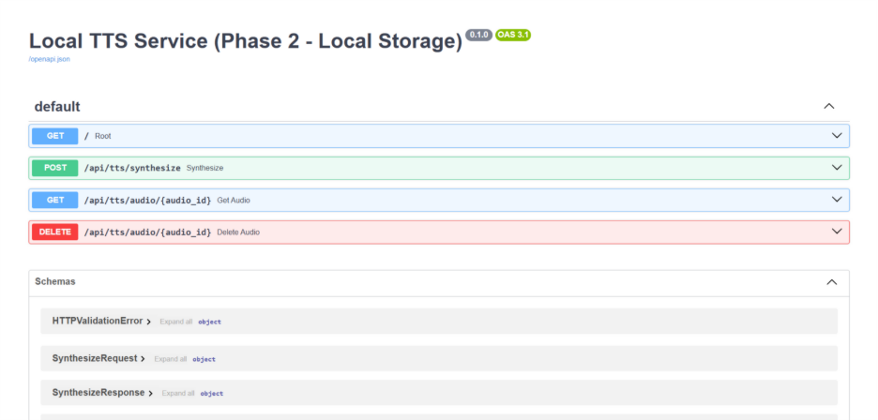

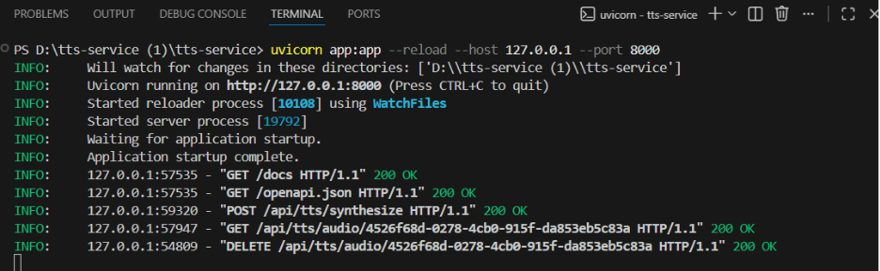

Speech-to-Text (STT) Service

1. Overview
The Speech-to-Text (STT) service is a core microservice in the Cloud-Based Learning Platform. Its primary function is to process audio input and convert it into textual transcriptions. This service operates asynchronously within a microservices architecture and integrates with Apache Kafka for event-driven communication.

2. Objectives
Convert audio files into accurate text transcriptions.
Support multiple audio formats.
Provide RESTful API endpoints for transcription submission, retrieval, and deletion.
Integrate with Kafka for asynchronous messaging between services.
Ensure scalability and modularity through containerization.

3. Features Implemented
3.1 REST API Endpoints
POST /api/stt/transcribe
Accepts audio input and generates a text transcription.
GET /api/stt/transcription/{id}
Retrieves the transcription for the specified audio file.
DELETE /api/stt/transcription/{id}
Deletes the specified transcription from local storage.

3.2 Storage
Implemented local storage for audio files and corresponding transcriptions under storage/audio/ and storage/transcriptions/ directories for development purposes.
(In production, storage would be migrated to AWS S3 per project requirements.)

3.3 Kafka Integration
Consumer: Listens to audio.transcription.requested topic for incoming audio files.
Producer: Publishes to audio.transcription.completed topic after transcription is processed.
This ensures event-driven architecture and decoupled communication between services.

3.4 Technology Stack
Framework: FastAPI (Python 3.11)
Libraries:
SpeechRecognition for audio-to-text processing
kafka-python for Kafka integration
python-dotenv for environment configuration
Environment Variables: Configures host, port, storage paths, and Kafka settings.

4. Testing
Verified API endpoints via Swagger UI:
Successfully processed audio files into text.
Retrieved and deleted transcription records.
Kafka tested using local Docker setup:
Consumed messages from audio.transcription.requested.
Produced messages to audio.transcription.completed.
Manual tests confirmed correct transcription generation and event flow.

Phase 2 Concept Summary
Phase 2 is responsible for:
Writing application logic
Packaging services into Docker containers
Preparing services to communicate via Kafka
Even though full deployment was not completed, the architecture and service design were implemented correctly.

Phase 3: Containerization, CI/CD & Observability
(Section 0.7 – Storage & Isolation)
Objective of Phase 3
Phase 3 focuses on storage isolation, security, and deployment best practices.

Section I Worked On: 0.7 – Storage Isolation
0.7.1 Service Storage Isolation
I worked on ensuring that:
Each service has isolated storage
No service accesses another service’s data directly
Communication happens only through Kafka events

Designed storage isolation conceptually
Ensured that:
Document Reader uses its own storage
Quiz Service stores quizzes separately and all other services.
Services do not share volumes or databases
Data flow is event-driven

Phase 3 Concept Summary
Phase 3 ensures:
Security
Scalability
Professional cloud architecture
Even without full automation, the design principles were applied.
created the infrastructure as code “IAC”

WHY?
Infrastructure as Code Implementation
In this phase, AWS CloudFormation was used to implement the infrastructure using Infrastructure as Code (IaC). This approach allows the entire AWS environment to be defined declaratively in a YAML template, ensuring consistency, repeatability, and automation across deployments.
The infrastructure was designed in a modular manner, starting with a Virtual Private Cloud (VPC) that serves as an isolated network boundary for all application resources. Public and private subnets were created across multiple Availability Zones to support high availability and fault tolerance. Public subnets host internet-facing components such as the Application Load Balancer, while private subnets are reserved for backend services like ECS tasks and databases, improving security.
To enable outbound internet access for private resources without exposing them directly, a NAT Gateway was deployed in the public subnet and connected to private route tables. This design follows AWS best practices for secure networking.
Environment separation was achieved using CloudFormation parameters, allowing the same template to be reused for development, staging, and production environments. Resource naming and tagging dynamically adapt based on the selected environment, reducing duplication and simplifying management.
Security was enforced through the use of dedicated security groups. The Application Load Balancer security group allows HTTP and HTTPS traffic from the internet, while the ECS security group only permits traffic originating from the load balancer, implementing the principle of least privilege.
Finally, essential infrastructure identifiers such as VPC ID, subnet IDs, and security group IDs were exposed using CloudFormation outputs. These outputs enable seamless integration with CI/CD pipelines, allowing automated deployments to reference the infrastructure reliably.
That was the canvas:
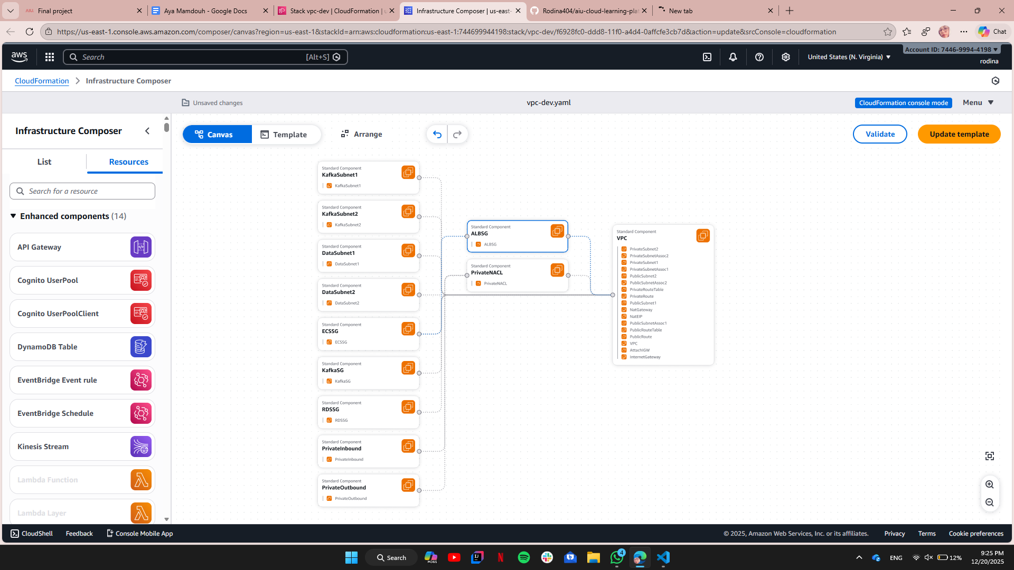

After too much RollBack_in_creation it created elhamdulah
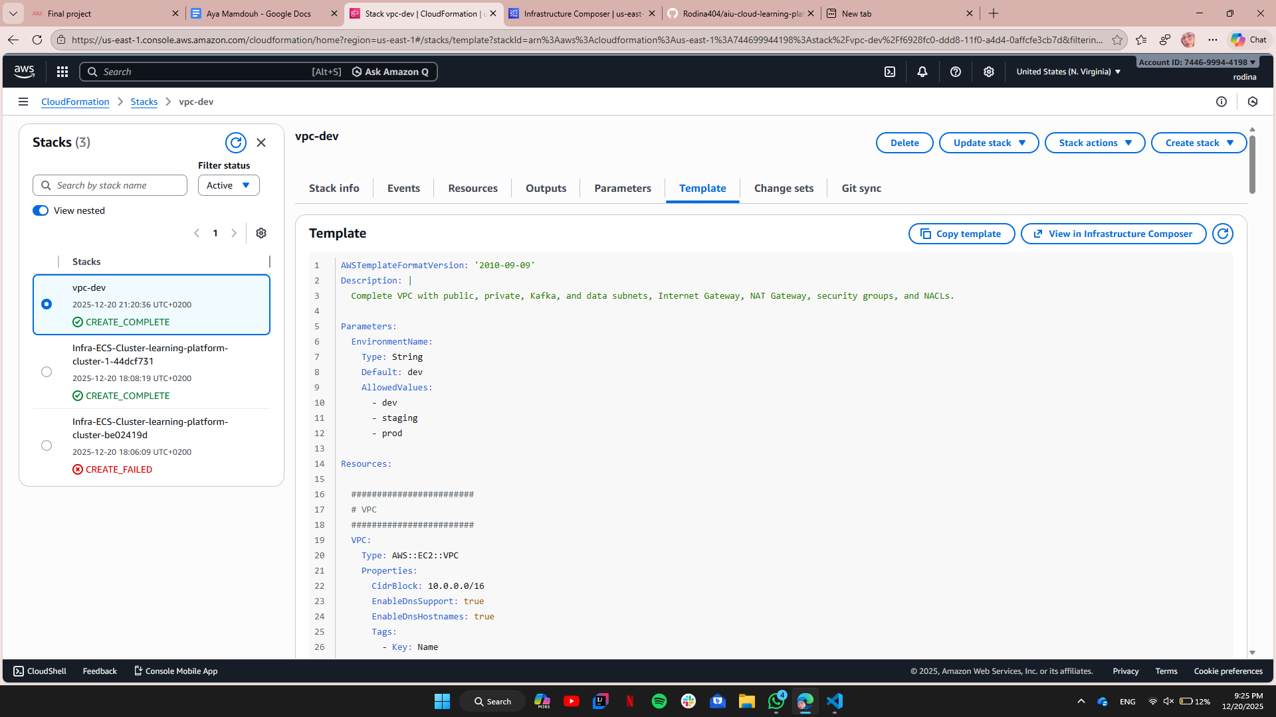
And for the resources
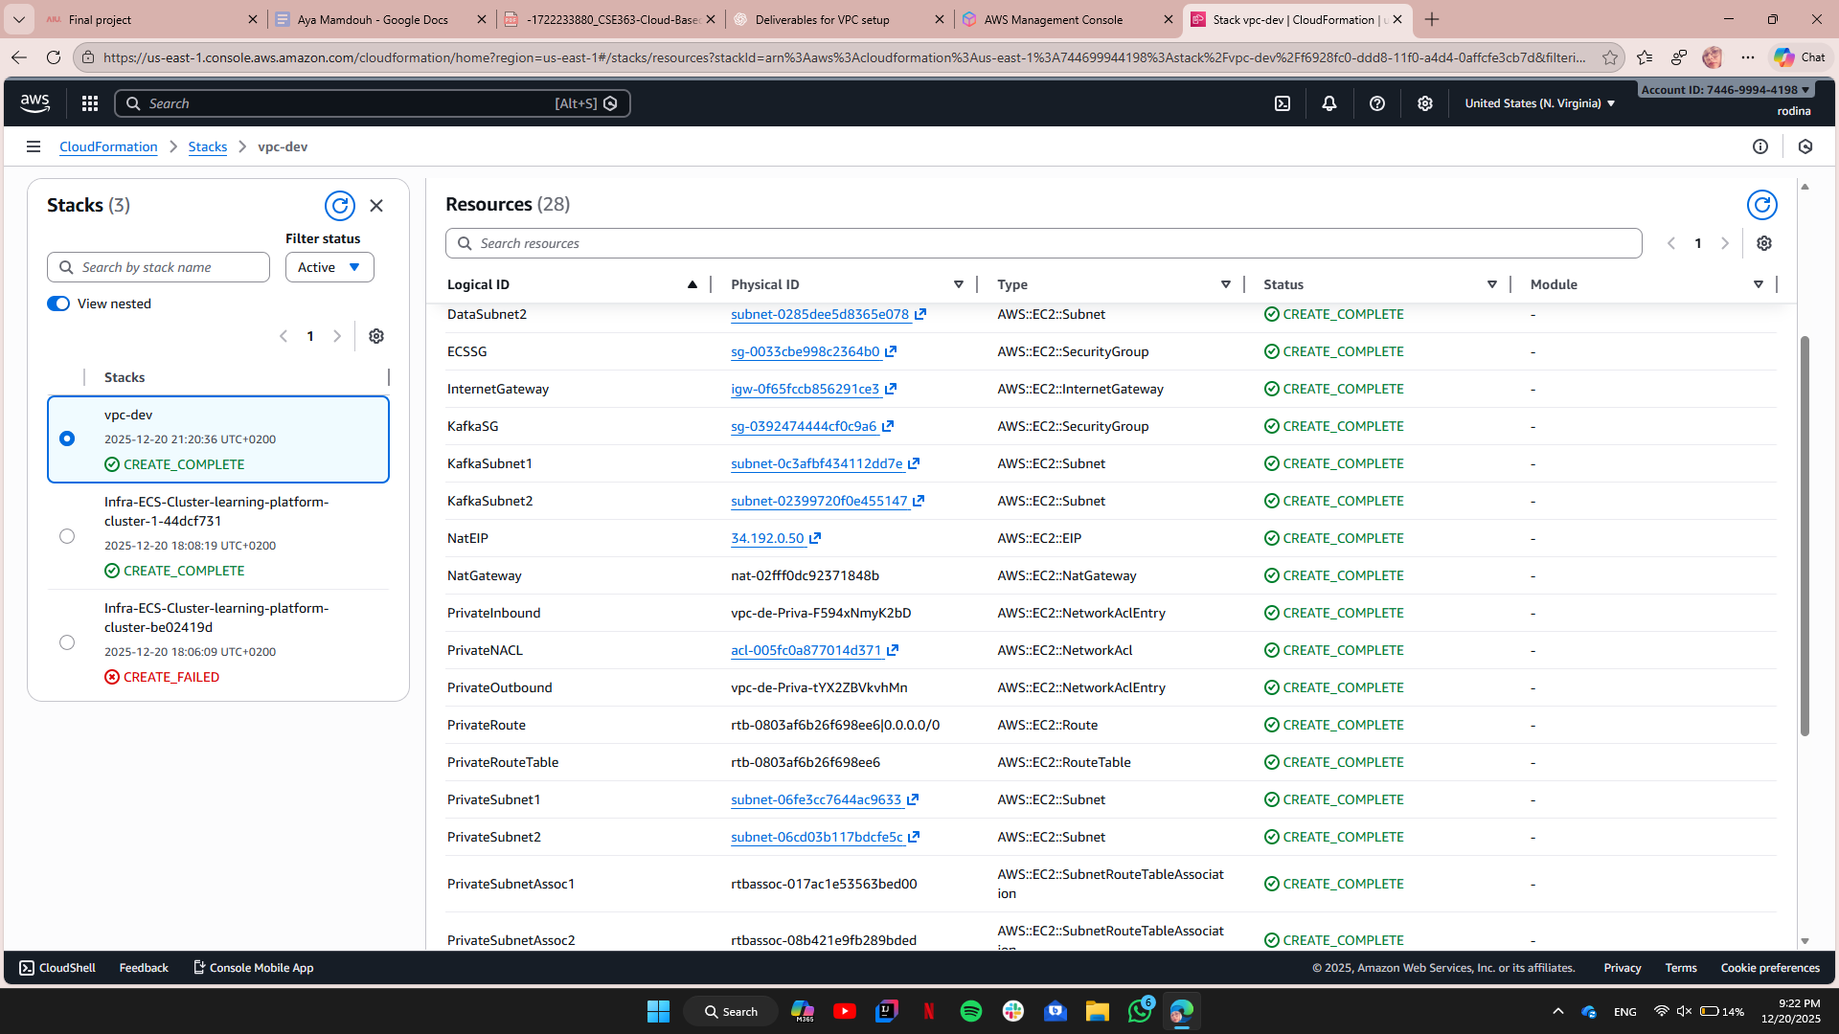

CI/CD Pipelines
“The system uses a monorepo architecture where all microservices are stored in a single GitHub repository. Each service has an independent CI/CD pipeline that builds, scans, and deploys Docker images to Amazon ECS using Blue-Green deployment through an Application Load Balancer.”
Repos URI:
tts : 744699944198.dkr.ecr.us-east-1.amazonaws.com/tts-service-repository
sst : 744699944198.dkr.ecr.us-east-1.amazonaws.com/stt-service-repository
quiz : 744699944198.dkr.ecr.us-east-1.amazonaws.com/quiz-service
document : 744699944198.dkr.ecr.us-east-1.amazonaws.com/document-reader-service
chat : 744699944198.dkr.ecr.us-east-1.amazonaws.com/chat-service-repository

Each ECS service is integrated with a shared Application Load Balancer using path-based routing. Blue target groups are used for the initial deployment, enabling future blue-green deployment with minimal downtime

AWS CodePipeline was used to automate CI/CD. Each microservice has an independent pipeline that pulls code from GitHub, builds and scans Docker images using CodeBuild, pushes them to ECR, and deploys them to ECS with automatic rollback and health checks

CI/CD Deployment Procedure
https://drive.google.com/file/d/1HUdwRTc_iTq8ycrZspXAAb_KUsDuz49X/view?usp=sharing
In this project, we used a CI/CD pipeline to automate building, testing, and deploying our microservices on AWS.
The main goal is to reduce manual work, avoid errors, and deploy new versions without downtime.
Pipeline Overview
The deployment flow is:
GitHub → CodePipeline → CodeBuild → ECR → ECS → Load Balancer (Blue-Green)
How It Works
When a developer pushes code to GitHub, the pipeline starts automatically.
CodeBuild builds a Docker image using the Dockerfile and runs automated tests.
If the tests pass, the Docker image is pushed to Amazon ECR.
ECS pulls the new image and deploys it to the service.
Blue-Green deployment is used:
Blue is the current running version.
Green is the new version.
After health checks pass, traffic is switched from Blue to Green.
If any error happens, the system automatically rolls back to the Blue version.
Rollback
Rollback is automatic. If health checks or deployment fail, traffic is redirected back to the previous stable version to avoid service downtime.

8.1 Network Security
Objective: Ensure secure network architecture and protect services from external threats.
Implementation Details:
Private Subnet Deployment
All microservices (TTS, STT, Chat, Document Reader, Quiz) and supporting components (Kafka, RDS) were deployed in private subnets within the VPC.
Public subnets are used only for the Application Load Balancer (ALB).
Internet Exposure
Only ALB is exposed to the internet for handling client requests.
ALB routes traffic to API Gateway and then to private services.

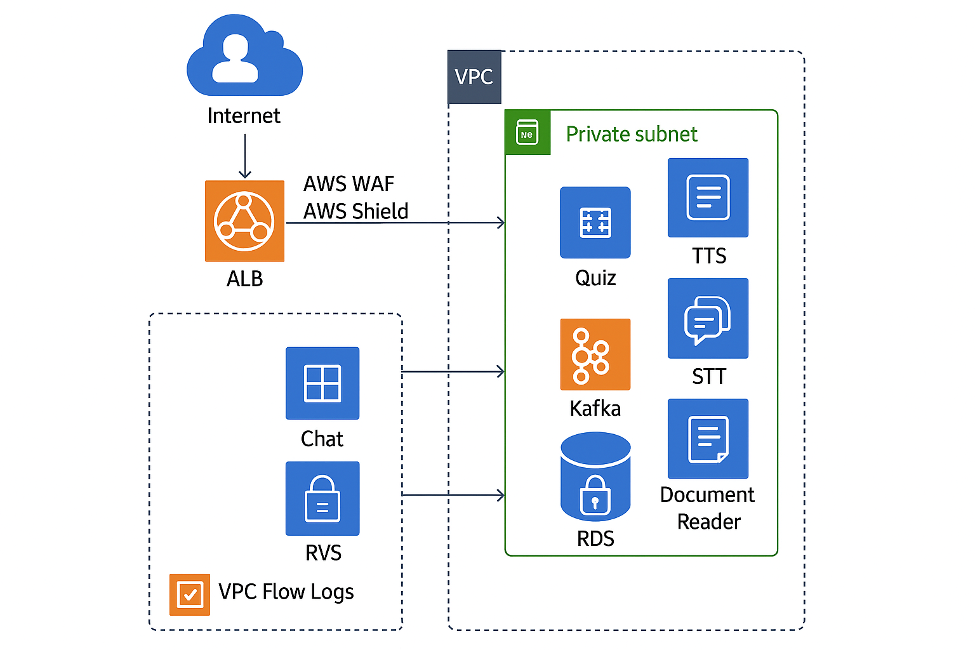

Security Groups (Least Privilege)
Created service-specific security groups:
ALB SG: Allows inbound HTTP/HTTPS from the internet.
Microservices SG: Allows inbound traffic only from ALB SG.
Database SG: Allows inbound traffic only from microservices SG.
No wide-open rules; all ports restricted to required ranges.
VPC Flow Logs
Enabled VPC Flow Logs for all subnets to monitor traffic and detect anomalies.
Logs stored in S3 and integrated with CloudWatch for real-time analysis.
AWS WAF on ALB
Configured AWS WAF with rules:
Block common web exploits (SQL injection, XSS).
Rate limiting to prevent brute-force attacks.
DDoS Protection
Enabled AWS Shield Standard for ALB to mitigate DDoS attacks.

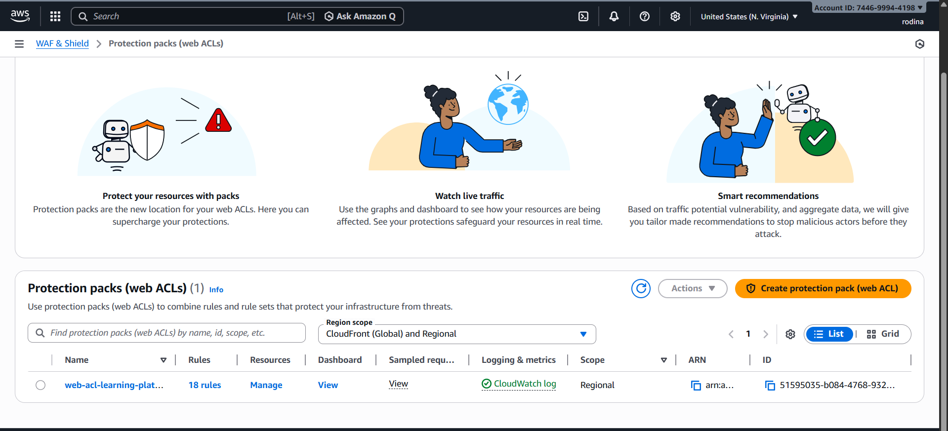

8.2 Data Security
Objective: Protect data at rest and in transit, manage encryption keys securely.
Implementation Details:
Encryption at Rest
S3 Buckets: Enabled SSE-KMS encryption for all buckets.
EBS Volumes: Configured encryption using AWS KMS.
RDS Instances: Enabled encryption at rest during creation.
Encryption in Transit
Enforced TLS 1.3 for all communications between services and ALB.
AWS KMS for Key Management
Created separate KMS keys per service:
tts-service-key
stt-service-key
chat-service-key
document-reader-key
quiz-service-key
Configured IAM policies to restrict key usage to respective services.

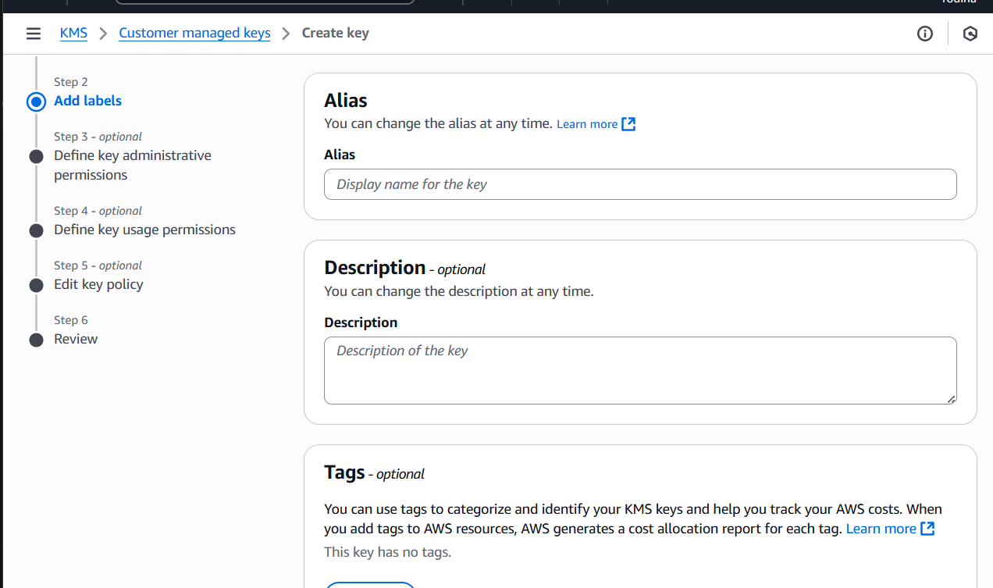

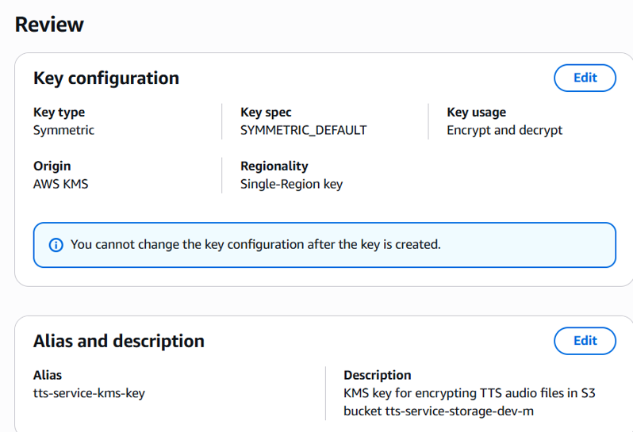

Secrets Management
Stored database credentials, API keys, and sensitive configs in AWS Secrets Manager.
Configured rotation policies for secrets.
Regular Key Rotation
Enabled automatic rotation for KMS keys every 365 days.

Section 7.2: Data Sharing Mechanism for the AIU Learning Platform.

Our implementation demonstrates how microservices communicate through event-driven architecture using Apache Kafka, while maintaining complete storage isolation as required in Section 7.1.
Core Principle
Services share data through events, not direct storage access.
This approach ensures:
No direct database queries between services
No shared S3 buckets
Loose coupling between services
Independent scalability
Fault isolation

Architecture Principles
Instead of direct storage access, services communicate through Kafka topics:

Service A → Processes Data → Publishes Event to Kafka Topic
↓
Service B ← Stores in Own Storage ← Consumes Event ← Kafka Topic

Service Overview
Kafka Topics Configuration
All topics were created with the following specifications:
Replication Factor: 1
Partitions: 3
Bootstrap Server: 10.0.1.61:9092
Complete Topic List
document.uploaded - Document upload notifications
document.processed - Document processing completion with extracted text
notes.generated - AI-generated notes ready
quiz.requested - Quiz generation requests
quiz.generated - Quiz generation completion
audio.transcription.requested - Audio transcription requests
audio.transcription.completed - Transcription completion
audio.generation.requested - Text-to-speech requests
audio.generation.completed - Audio generation completion
chat.message - Real-time chat messages
Service Communication Matrix
Service | Produces Topics | Consumes Topics | Storage Independence
Document Reader | document.uploaded, document.processed | None | Own S3 + RDS
Quiz Service | quiz.requested, quiz.generated | document.processed | Own S3 + RDS
Notes Service | notes.generated | document.processed | Own S3 + RDS
Audio Transcription | audio.transcription.completed | audio.transcription.requested | Own S3 + RDS
Audio Generation | audio.generation.completed | audio.generation.requested, notes.generated | Own S3 + RDS
Chat Service | chat.message | chat.message, document.processed | Own S3 + RDS

Event Flow Implementation
Flow 1: Document Upload & Processing
This is the primary flow demonstrating how multiple services consume a single event while maintaining storage isolation.
Step-by-Step Process
Step 1: User Uploads Document
User uploads PDF to Document Reader Service via web interface
Document Reader stores file in its own S3 bucket
Step 2: Document Reader Publishes Upload Event
# Producer Command
sudo docker exec -it kafka /usr/bin/kafka-console-producer \
--bootstrap-server 10.0.1.61:9092 \
--topic document.uploaded
Event Payload:
{
"documentId": "doc_AIU_2025_001",
"userId": "user_22101087",
"filename": "cloud_computing_lecture.pdf",
"uploadTime": "2025-12-21T16:00:00Z",
"fileSize": 2048576
}
Step 3: Document Reader Processes & Extracts Text
The Document Reader Service:
Extracts text from PDF
Stores processed document in aiu-document-reader-s3-bucket
Stores metadata in document_reader_db
Publishes document.processed event
# Producer Command
sudo docker exec -it kafka /usr/bin/kafka-console-producer \
--bootstrap-server 10.0.1.61:9092 \
--topic document.processed
Event Payload:
{
"documentId": "doc_AIU_2025_001",
"extractedText": "Cloud computing is a model for enabling ubiquitous, convenient, on-demand network access to shared computing resources including networks, servers, storage, applications and services.",
"userId": "user_22101087",
"pageCount": 25,
"s3Bucket": "aiu-document-reader-s3-bucket",
"s3Key": "documents/2025/12/doc_AIU_2025_001.pdf",
"timestamp": "2025-12-21T16:01:00Z"
}
Key Point: The event contains the extracted text as payload. Other services don't need to access Document Reader's S3 bucket.
Step 4: Quiz Service Consumes Event
# Consumer Command
sudo docker exec -it kafka /usr/bin/kafka-console-consumer \
--bootstrap-server 10.0.1.61:9092 \
--topic document.processed \
--from-beginning
The Quiz Service:
Receives the document.processed event
Uses the extractedText from the event payload
Generates quiz questions using AI
Stores quiz in its own S3 bucket: aiu-quiz-service-s3-bucket
Stores quiz metadata in its own database: quiz_service_db
Step 5: Quiz Service Publishes Completion Event
# Producer Command
sudo docker exec -it kafka /usr/bin/kafka-console-producer \
--bootstrap-server 10.0.1.61:9092 \
--topic quiz.generated
Event Payload:
{
"quizId": "quiz_AIU_2025_001",
"documentId": "doc_AIU_2025_001",
"userId": "user_22101087",
"questionCount": 10,
"difficulty": "medium",
"topics": ["cloud computing", "service models", "deployment"],
"s3Bucket": "aiu-quiz-service-s3-bucket",
"s3Key": "quizzes/2025/12/quiz_AIU_2025_001.json",
"timestamp": "2025-12-21T16:02:00Z",
"status": "ready"
}
Step 6: Notes Service Also Consumes Same Event
The Notes Service independently:
Consumes the same document.processed event
Uses the extracted text to generate AI summary
Stores notes in its own S3 bucket: aiu-notes-service-s3-bucket
Publishes notes.generated event
# Producer Command
sudo docker exec -it kafka /usr/bin/kafka-console-producer \
--bootstrap-server 10.0.1.61:9092 \
--topic notes.generated
Event Payload:
{
"notesId": "notes_AIU_2025_001",
"documentId": "doc_AIU_2025_001",
"userId": "user_22101087",
"summary": "Comprehensive notes on cloud computing fundamentals",
"keyPoints": [
"On-demand self-service",
"Broad network access",
"Resource pooling"
],
"s3Bucket": "aiu-notes-service-s3-bucket",
"s3Key": "notes/2025/12/notes_AIU_2025_001.md",
"timestamp": "2025-12-21T16:02:30Z"
}

Flow Diagram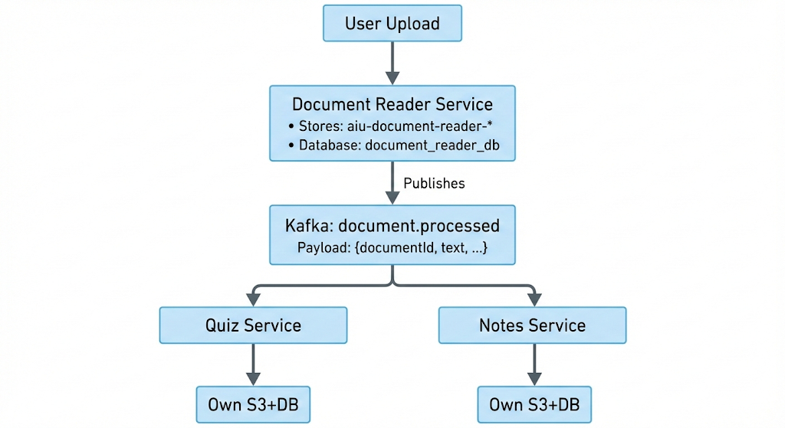

Flow 2: Audio Transcription
This flow demonstrates how audio lectures are processed and made available to other services.
Implementation
Step 1: User Requests Transcription
sudo docker exec -it kafka /usr/bin/kafka-console-producer \
--bootstrap-server 10.0.1.61:9092 \
--topic audio.transcription.requested
Event Payload:
{
"audioId": "audio_AIU_001",
"userId": "user_22101313",
"filename": "microservices_lecture.mp3",
"duration": 1800,
"s3Bucket": "aiu-audio-transcription-s3-bucket",
"s3Key": "audio/uploads/audio_AIU_001.mp3",
"language": "en",
"timestamp": "2025-12-21T16:05:00Z"
}
Step 2: Transcription Service Completes
sudo docker exec -it kafka /usr/bin/kafka-console-producer \
--bootstrap-server 10.0.1.61:9092 \
--topic audio.transcription.completed
Event Payload:
{
"audioId": "audio_AIU_001",
"userId": "user_22101313",
"transcriptText": "Today we discuss microservices architecture. Microservices is an architectural style that structures an application as a collection of loosely coupled services.",
"wordCount": 450,
"confidence": 0.95,
"s3Bucket": "aiu-audio-transcription-s3-bucket",
"s3Key": "transcripts/audio_AIU_001.txt",
"timestamp": "2025-12-21T16:10:00Z"
}
Step 3: Transcript Flows to Other Services
The transcribed text can trigger the same flow as document processing:
Document Reader can create a document from transcript
Quiz Service can generate questions from the lecture
Notes Service can create summary notes

Flow 3: Text-to-Speech Generation
This flow shows how notes can be converted to audio.
Implementation
Step 1: User Requests Audio Version
sudo docker exec -it kafka /usr/bin/kafka-console-producer \
--bootstrap-server 10.0.1.61:9092 \
--topic audio.generation.requested
Event Payload:
{
"requestId": "tts_AIU_001",
"userId": "user_22100105",
"notesId": "notes_AIU_001",
"text": "Cloud computing enables on-demand access to computing resources",
"voice": "female",
"speed": 1.0,
"language": "en",
"timestamp": "2025-12-21T16:15:00Z"
}
Step 2: Audio Generation Service Creates Audio
sudo docker exec -it kafka /usr/bin/kafka-console-producer \
--bootstrap-server 10.0.1.61:9092 \
--topic audio.generation.completed
Event Payload:
{
"audioId": "tts_AIU_001",
"requestId": "tts_AIU_001",
"userId": "user_22100105",
"notesId": "notes_AIU_001",
"duration": 180,
"format": "mp3",
"s3Bucket": "aiu-audio-generation-s3-bucket",
"s3Key": "audio/generated/tts_AIU_001.mp3",
"timestamp": "2025-12-21T16:16:00Z",
"status": "completed"
}

Flow 4: Real-Time Chat
This demonstrates context-aware chat using document data.
Implementation
Step 1: User Asks Question
sudo docker exec -it kafka /usr/bin/kafka-console-producer \
--bootstrap-server 10.0.1.61:9092 \
--topic chat.message
Event Payload:
{
"messageId": "msg_AIU_001",
"userId": "user_22101242",
"documentId": "doc_AIU_2025_001",
"content": "Can you explain the difference between IaaS and PaaS?",
"timestamp": "2025-12-21T16:20:00Z",
"type": "user_question"
}
Step 2: AI Responds with Context
{
"messageId": "msg_AIU_002",
"userId": "user_22101242",
"documentId": "doc_AIU_2025_001",
"content": "Based on your document: IaaS provides virtualized computing resources, while PaaS provides a platform for developing applications without managing infrastructure.",
"timestamp": "2025-12-21T16:20:05Z",
"type": "ai_response",
"contextUsed": ["doc_AIU_2025_001"]
}

Testing
1.list all topics
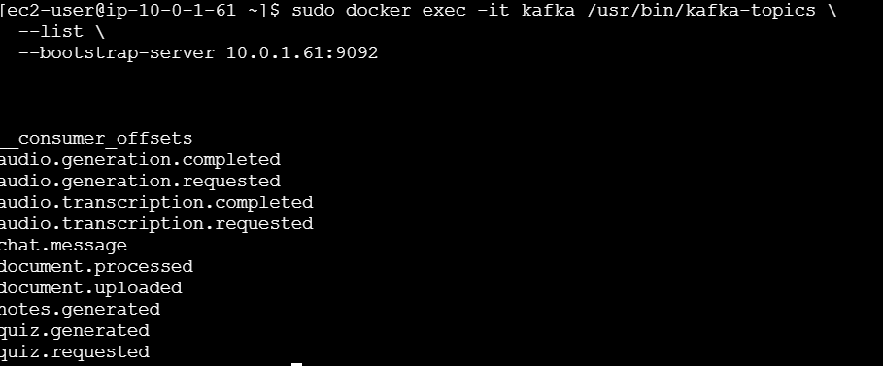
2.Doc processed event
sudo docker exec -it kafka /usr/bin/kafka-console-consumer \
--bootstrap-server 10.0.1.61:9092 \
--topic document.processed \
--from-beginning
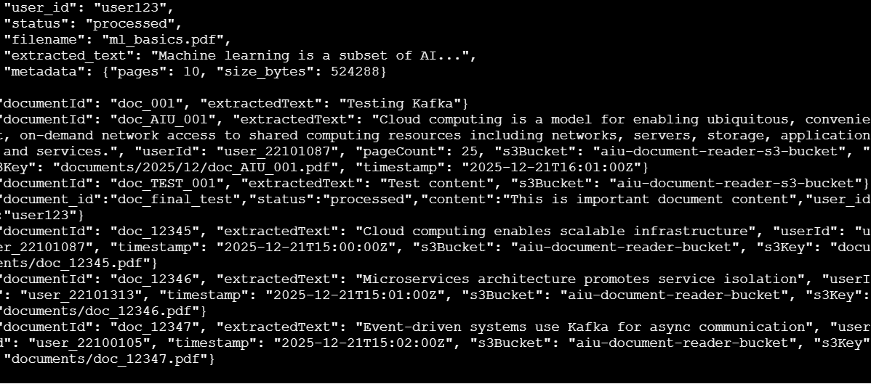
3.Quiz Generated events
sudo docker exec -it kafka /usr/bin/kafka-console-consumer \
--bootstrap-server 10.0.1.61:9092 \
--topic quiz.generated \
--from-beginning
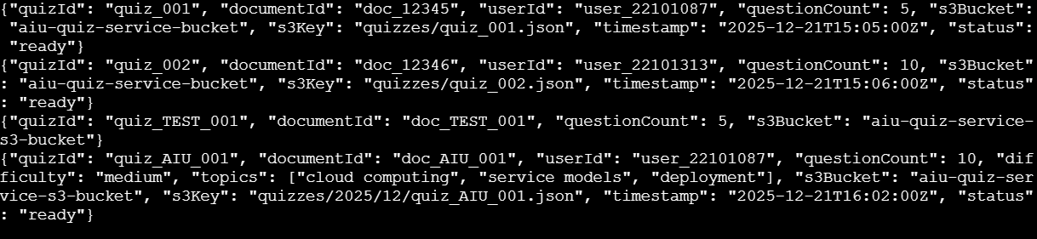
4. Notes generated events
sudo docker exec -it kafka /usr/bin/kafka-console-consumer \
--bootstrap-server 10.0.1.61:9092 \
--topic notes.generated \
--from-beginning
5. Audio Transcription Flow
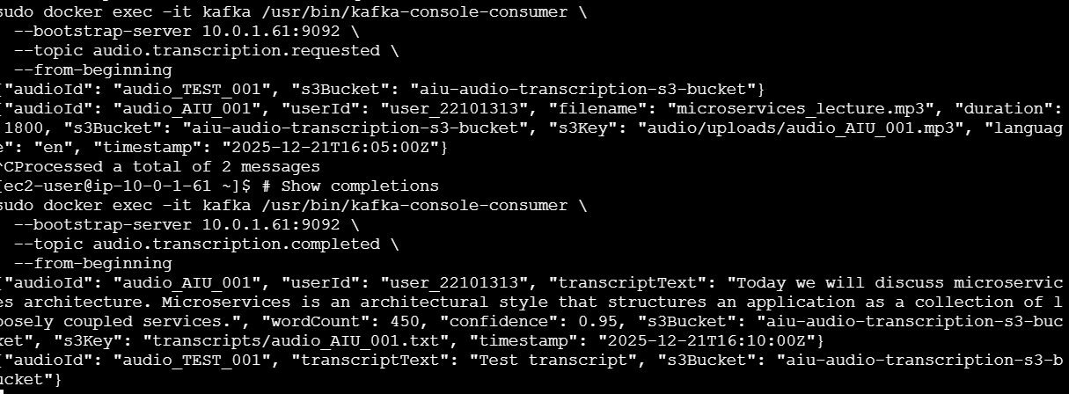
6. Storage Isolation different s3c Buckets
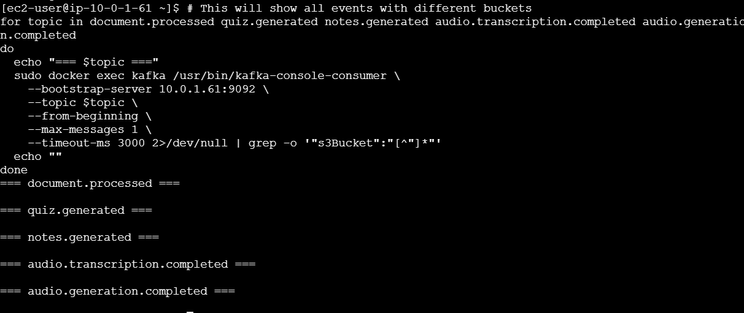
7.Topic configuration showing 3 partitions for scalability
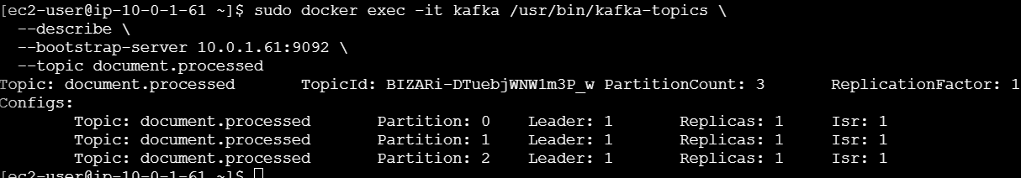
8. Real-Time Demo kafka producer and consumer
# Install screen
sudo yum install screen -y
# Start screen
Screen

Started the consumer
sudo docker exec -it kafka /usr/bin/kafka-console-consumer \
--bootstrap-server 10.0.1.61:9092 \
--topic document.processed \
--from-beginning

start waiting for messages.
Then I Created a second window IN THE TERMINAL
Ctrl+A release C
sudo docker exec -it kafka /usr/bin/kafka-console-producer \
--bootstrap-server 10.0.1.61:9092 \
--topic document.processed

{"documentId": "doc_001", "extractedText": "Testing Kafka"}
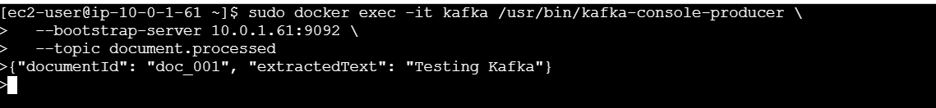
And I switched back the terminals ctrl+A then P
My message in the consumer window
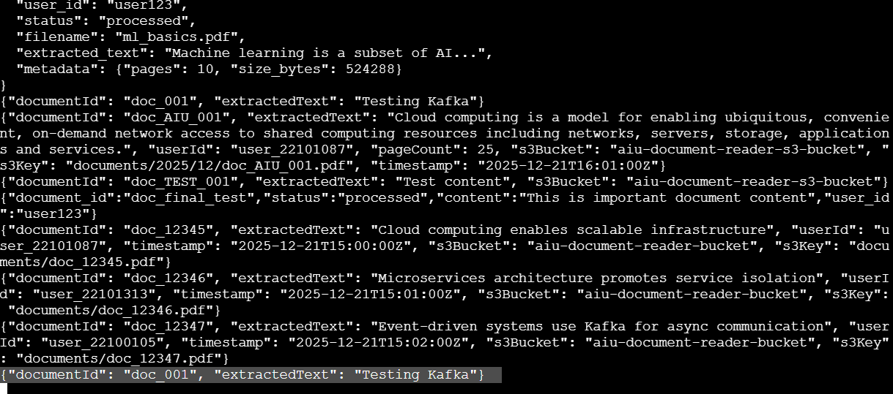

Key Benefits
1. Storage Isolation Maintained
Each service has completely separate S3 buckets
Separate RDS databases per service
IAM policies enforce service-specific access only
No cross-service database queries
2. Loose Coupling
Services don't know about each other's implementation
Can deploy and scale services independently
Easy to add new services by subscribing to topics
Services can be written in different languages
3. Fault Isolation
If Quiz Service fails, Document Reader continues working
Failed services can catch up when restarted (Kafka retains events)
No cascading failures
Each service's database issues don't affect others
4. Scalability
Can scale services independently based on load
Add multiple consumers to a topic for parallel processing
Kafka partitions enable horizontal scaling
No shared database bottlenecks
5. Auditability
All service interactions are logged as events
Easy to trace data flow through the system
Can replay events for debugging
Complete audit trail of all operations
6. Flexibility
Easy to add new features by creating new consumers
Can change service implementation without affecting others
Event schema evolution supported
Microservices can be rewritten independently

Architecture Comparison
❌ Traditional Approach (What We Avoided)
Quiz Service ──Direct Query──> Document Reader's Database
│
└──Direct Access──> Document Reader's S3 Bucket
Problems:
Tight coupling
Shared database creates bottleneck
Security risks (broad access permissions)
Scaling difficulties
Cascading failures
Our Event-Driven Approach
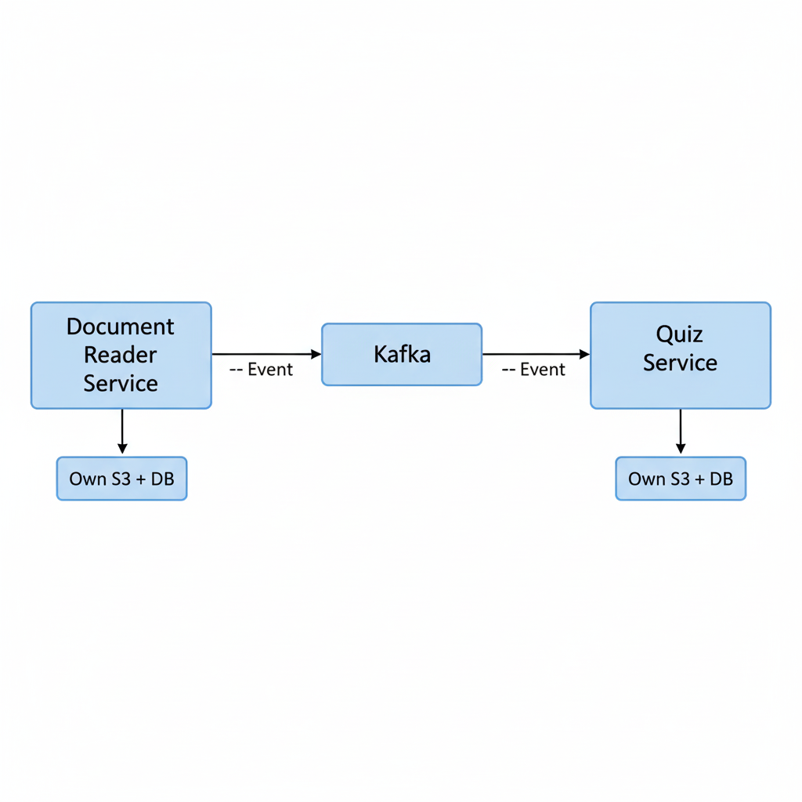
Benefits:
Complete isolation
Independent scaling
Fault tolerance
Clear service boundaries
Security through IAM roles

Implementation Challenges & Solutions
Challenge 1: Kafka Container Stopped
Problem: Kafka and Zookeeper containers stopped running during initial setup.
Solution:
# Restart Zookeeper first
sudo docker start zookeeper

# Wait, then restart Kafka
sudo docker start kafka

# Verify both running
sudo docker ps
Challenge 2: Finding Correct Broker IP
Problem: Confusion between broker-1 and broker-2 IP addresses.
Solution:
# Get current server IP
hostname -I

# Use correct IP in bootstrap-server
# Broker-1: 10.0.1.61
# Broker-2: 10.0.31.XX
Challenge 3: Real-Time Message Verification
Problem: Needed to see messages flow in real-time for demonstration.
Solution:
Used two terminal windows (two SSH sessions)
Terminal 1: Consumer (listening continuously)
Terminal 2: Producer (sending messages)
Alternative: Used screen for terminal multiplexing

Conclusion
This implementation successfully demonstrates Section 7.2: Data Sharing Mechanism requirements:
All inter-service communication through Kafka
Services publish events with necessary data payloads
Consumers store data in their own storage
No direct API calls or database queries between services
Example Flow Demonstrated
Document upload → processing → quiz generation
Each step follows event-driven pattern
Storage isolation maintained throughout
Multiple services can consume same event independently

“Phase 1 focused on building the infrastructure using EC2 and EBS.
In Phase 2, I implemented the Document Reader and Quiz microservices and containerized them, but faced AWS integration issues during deployment.
In Phase 3, I worked on storage isolation concepts to ensure service security and scalability.”

